Review of CWM Radioactive Sampling Program
In the Proposed RMU-2 Development Areas

October 2014

On behalf of Niagara County

By
Marvin Resnikoff, Ph.D.
Radioactive Waste Management Associates

Summary

This report reviews the radioactive sampling program by Chemical Waste Management’s (CWM) contractors, URS, EnSol and LATA in the proposed RMU-2 development areas. This program consisted of a gamma walkover surface survey and subsurface investigation of the RMU-2 footprint, with a more detailed investigation of facultative pond 8 (FacPond 8). In general, we have little confidence that the CWM investigations are capable of detecting, with reasonable certainty, radioactive contamination on the CWM property. Based on historical documentation provided by the Atomic Energy Commission (AEC) and its successors, such contamination could be widespread and diffuse. However, the work by URS, EnSol and LATA fails to comport with relevant guidelines for the investigation of subsurface radiological contamination. Because this work forms the basis for the soil excavation plan (SEMMP) provided in the RMU-2 Project application, there is no reasonable assurance that excavation will not disperse radionuclides into the environment, especially into excavation work areas. Particular attention should have been paid to areas of the proposed footprint that were previously contaminated, rather than sparsely surveying the entire proposed footprint. CWM’s contractors should have first carried out a historical assessment. While a surface gamma walkover survey is one screening method, as illustrated in FacPond 8, it is entirely unsatisfactory for detecting subsurface contamination. Surface contamination has been redistributed and buried by landfill activity further limiting the usefulness of a gamma surface survey. However, the work by URS, EnSol and LATA utilized a surface survey to determine locations for subsurface investigations. Finally, the inert gas radon within FacPond 8 was not sampled and the dose modeling program (RESRAD) employed by CWM’s contractor GRD suppressed the radon pathway. RESRAD is designed for a flat surface and is not capable of modeling the FacPond 8 geometry which includes 22-foot high berms. GRD employed RESRAD to calculate a radiation dose to a worker, but omitted the potential lung dose due to radon inhalation.

Historical Assessment

None of the contractors conducted a historical assessment to determine where radioactive waste was stored or buried. Before undertaking a screening or detailed survey, one should know where to look. This is recommended by MARSSIM. MARSSIM is more than a guide for a final status survey. It is a “systematic approach for planning, conducting, evaluating, and documenting environmental radiological surveys.”

According to MARSSIM an historical site assessment “identifies potential, likely, or known sources of radioactive material and radioactive contamination based on existing or derived information.” This serves as a guide on whether the unit is impacted by contamination or not. This is information that is useful to scoping and characterization surveys. A historical assessment would show that landfill and lagoon construction moved contaminants around the CWM site.

A 1982 report by Aerospace Corporation is especially useful in characterizing the properties owned by CWM. That report details, after a review of historical documents, the quantities of radioactive materials brought to the LOOW site and where this material was stored or buried. The attached Fig. 1 shows the original Atomic Energy Commission site portion of LOOW. While other figures in the report show where radioactive material was disposed or stored, for our purposes, Fig. 2, also attached, is the most useful. Figure 2 is a summary of a surface gamma survey conducted in the 1971-1972 time frame. Higher dose rates were present near railroad tracks in federal Vicinity Property E and in Vicinity Properties C and F. Some of those areas lie within the RMU-2 footprint. In particular, Fac Pond 3 lies within Vicinity Property F and Fac Pond 8 lies within Vicinity Property C. Proposed landfill RMU-2 lies within parts of Vicinity Properties C, E, E’ and F. The regions of these Vicinity Properties, where gamma dose rates are higher, are shown in Fig.2. It is important to note that Fig. 2 shows gamma dose rates due to surface contamination and not subsurface contamination. CWM acknowledges that a portion of the former railroad line north of “M” Street is located within the footprint of RMU-2. “Based on previous investigations, residual contamination remains in this area. The railroad bed material and residual contamination will be excavated and will be segregated and characterized for disposal.” Based on this contamination, MARSSIM would classify the RMU-2 footprint as category 1, or likely to be impacted by radioactive contaminants.

ORAU and CWM Surveys
Since 1972 when this survey was taken, further decontamination, in vicinity properties C and F may have occurred, and also earth may have been moved to construct Fac Pond 8. More recently, 85 cubic yards of contaminated earth were removed from Fac Pond 8, with composite radium-226 concentrations of 191 pCi/g, despite the fact that gamma surface surveys could not detect this contamination, as we discuss below. Oak Ridge Associated University (ORAU) detected extensive contamination within the RMU-2 footprint and in Fac Pond 8. We summarize the ORAU findings next and attach a report that goes into the matter in greater detail.

The vicinity properties are shown in Fig. 2. The vicinity properties, superimposed on the footprint of RMU-2, are shown in Fig. 3. As seen in Fig. 3, the vicinity properties associated with RMU-2 are C, D, E, E’ and F. Maps that show the location of contaminated soil within each Vicinity Property are not included here, but are contained in the attached report

Vicinity Property D. According to U.S. Department of Energy (DOE), LOOW Vicinity Property D is certified as in compliance with the decontamination criteria and standards applicable to the remedial actions at NFSS. However, during a 1983 walkover survey, elevated areas of direct radiation were measured in LOOW Vicinity Property D CWM’s initial gamma-radiation walkover survey found 460 locations with radiation readings above 16,000 cpm. The maximum readings were as high as 91,120 cpm, 113,700 cpm, 896,900 cpm, and 897,200 cpm. These 460 locations were revisited by CWM and inexplicably only ten locations were confirmed to contain elevated levels of radiation. In 1983, a walkover survey performed by ORAU found the portion of LOOW Vicinity Property D that contains landfill SLF-12 to contain elevated levels of surface radiation and radionuclide concentrations in soil. According to the post-remedial action report published in January of 1989, these locations within LOOW Vicinity Property D were subsequently decontaminated, and DOE verified that the vicinity is in compliance with the decontamination criteria and standards applicable to the remedial actions at NFSS. In agreement with ORAU’s 1983 findings, CWM’s most recent analysis also found elevated areas of radiation over CWM’s landfill SLF-12.

Vicinity Property E. LOOW Vicinity Property E lies directly south of LOOW Vicinity Property D. During the 1983 walkover survey of LOOW vicinity properties, ORAU found two major areas within LOOW Vicinity Property E that contained elevated concentrations of radionuclides in soil that exceeded EPA and/or NRC criteria. These areas are located in the southwest and northwest portions of LOOW Vicinity Property E The southern boundary of LOOW Vicinity Property E is shaped by an abandoned railway bed. Locations surrounding the abandoned railway bed were all found to exhibit elevated levels of radiation during the CWM 2008 walkover survey of its investigation areas. The railroad ties and stone bed material from the abandoned railroad were removed during the construction of RMU-1. In 1983, ORAU found elevated concentrations of radiation in the soil of LOOW Vicinity Property E just north of the railway bed. In 1983 soil sampling along the southern berm of Lagoon 6 indicated the presence of metal containers buried 20 to 30 centimeters below the surface. Ground penetrating radar indicated the presence of 22 buried targets. Radiation concentrations in the soils from this area indicated that the containers were contaminated or contained contaminated residues. No post-remediation report published after 1984 indicates that the containers buried south of Lagoon 6 in Vicinity Property E were ever removed. The eastern portion of LOOW Vicinity Property E is included in the proposed footprint of RMU-2. The presence of the abandoned railway bed in LOOW Vicinity Property E indicates that Vicinity Property E is more than likely contaminated with radioactive material within the railbed.

Vicinity Property E’. LOOW Vicinity Property E’ lies just south of LOOW Vicinity Property E. An ORAU 1983 analysis found a large area of elevated radionuclide concentrations in the soil of the western, central, and eastern portions of LOOW Vicinity Property E’. In 1983, ORAU found that the areas containing elevated surface levels and concentrations of radionuclides in the soil within LOOW Vicinity Property E’ completely surrounded a portion of the abandoned railway bed. The portion of the abandoned railroad bed in LOOW Vicinity Property E’ found by ORAU to contain elevated surface radioactive concentrations lies directly within the boundaries of the proposed RMU-2 Waste Site. A memo from an ORAU author released in 1982 details another possible source of radiological contamination in this area. In 1982, a 10-inch thick layer of contamination was found to exist two feet below the surface at a location described to be just north of the two PCB storage tanks located in LOOW Vicinity Property E’. This layer of contamination extends over an approximate area of 30 meters by 15 meters. Ra-226 concentrations in the soil of this contaminated area ranged up to 300 pCi/g. A 1999 study conducted by the U.S. Army Corps of Engineers also found radioactive contamination in Vicinity Property E’ in a location similar to that described in the 1982 ORAU memo.

Vicinity Property F. LOOW Vicinity Property F is located directly south of LOOW Vicinity Property E’ and north of NFSS. Several areas within the eastern portion of LOOW Vicinity Property F are included in the proposed RMU-2 Waste footprint. A 1984 ORAU survey of LOOW Vicinity Property F found the vicinity to contain several locations of elevated surface radiation and radionuclide concentrations in soil that exceeded the criteria for FUSRAP sites. Exposure rates measured in Facultative Pond 3, located along the eastern edge of LOOW Vicinity Property F, exceeded 4 μR/h which is approximately equivalent to the NRC regulation of 25 mrem/year. The areas of Facultative Pond 3 found to exhibit elevated exposure rates are within the proposed RMU-2 footprint.

Fac Pond 8 Characterization

CWM cannot provide any reasonable assurance that all radioactive contamination beneath the surface of Fac Pond 8 area has been located because its contractors have not properly characterized the area. A surface gamma survey did not identify subsurface contamination, but subsurface contamination was later found with subsurface probes.

Fac Pond 8 is located near the southern border of the CWM property, adjacent to RMU-1. According to the application, Fac Pond 8 would be excavated in the first phase of RMU-2 construction. It was constructed in 1978, long past waste burial operations at the LOOW site. From the top of the side berms, the pond is 500' by 500', with an average depth of 22'. The pond was drained prior to EnSol’s surface scan and sampling. In 2010, EnSol conducted the first detailed characterization of Fac Pond 8, including a survey scan and sample collection. This followed initial radiological surveys by URS in 2005 and 2007. For characterization, EnSol divided Fac Pond 8 into 12 survey units, four survey units (9-12) for the side berms, and eight survey units (1-8) for the floor, as seen in Fig. 4. Based on EnSol’s surface gamma survey and soil samples of Fac Pond 8, two of the sections, 6 and 10, which are adjacent, had Ra-226 concentrations above background, but SU9 was considered clean.
A 1971 – 1972 AEC survey identified surface contamination near the southwest corner of Vicinity Property C, where Fac Pond 8 is located. In 1984, Oak Ridge Associated Universities (ORAU) stated, “This finding suggests possible storage or shallow burial of contaminated material may have occurred.” No records presented by CWM show how Fac Pond 8 was constructed, particularly the berms surrounding the 500‘ by 500’ former pond. It is reasonable to assume that the berms were constructed with a bulldozer leveling the flat center of the pond, thereby pushing contaminated soil into the berms. A foot of soil attenuates gamma radiation in the U-238, Th-232 decay chains by 98%. Accordingly, a surface scan with radiation detectors cannot measure subsurface contamination.

A careful review of the history of Vicinity Property C should have led LATA/EnSol to conduct push probes of the entire Fac Pond 8 in a systematic array. However, LATA/URS conducted only surface surveys that could not detect subsurface radioactive contamination.

In July 2012, LATA conducted a subsurface survey of SU 9 of Fac Pond 8. This was a section that was previously considered, in the EnSol 2010 survey, decontaminated. But LATA’s subsurface examination showed that Section 9 was contaminated by a vein of contamination greater than 3 feet below the surface. The finding of subsurface contamination in SU9 is deeply disturbing because this survey unit was considered clean and raises the issue of EnSol’s competence. Over 85 yd³ of soil was excavated, with composite Ra-226 concentrations very high, 191 pCi/g. Subsequent to this excavation, the sum of fractions calculation showed this area remained contaminated after remediation. Upon that finding, LATA should have proceeded to conduct a systematic array of soil borings throughout the entire Fac Pond 8 area, but did not.

LATA’s methodology and results in SU 9 raise the basic question whether or not contamination remains at other SU’s within Fac Pond 8. As noted above, surface gamma surveys cannot identify contamination that resides one to three feet below the surface. Only a carefully plotted array of locations for sampling with push probes, in accordance with MARSSIM, will answer the question of whether the site has been decontaminated to regulatory standards. Despite the sampling failures, CWM states that “the remaining closure activities for Fac Pond 8 include the removal of soil in the north berm containing radiological constituents above established cleanup levels for the pond and regrading of the pond.” However, regrading the pond in light of the failure to characterize the area as a whole will, under the circumstances, likely move remaining radiological contaminants around the area, and disperse some contaminants into the atmosphere, and not remove contaminants from the area outside the north berm. Until a final status survey is completed, it cannot be known whether radiological contaminants in the Fac Pond 8 area will be mobilized and released to the environment by excavation of RMU-2.

CWM's November 16, 2004 letter asserts that , MARSSIM does not include procedures for subsurface sampling. CWM’s understanding of MARSSIM is incorrect. NRC guidance on this issue can be found in Section 1 and 11.1 of Appendix E in NUREG-1727 NMSS Decommissioning Standard Review Plan, clearly showing that subsurface sampling is within the scope of MARSSIM guidelines. None of CWM’s contractors have followed the MARSSIM guidance. NYSDOH alerted CWM in its letter dated 12/14/04 that an adequate subsurface investigation in compliance with NUREG-1727 and MARSSIM was among the important data gaps the agency expected CWM to fill.

Further, it appears that URS did conduct a gamma survey of the subsurface probes, as shown in the attached Fig. 5.

It is important to point out that SU9 in Fac Pond 8, was sampled with 15 push probes in a 2,000 m² surface area. In contrast, the more recent push probe survey by URS for Fac Pond 5 employed 45 push probes for an area 40,000 m² area, or a coverage almost 7 times less dense.

Radon Concentrations in Fac Pond 8

On August 14, 2014, CWM submitted a report to NYSDEC that estimated the potential radiation dose to workers who would be remediating Fac Pond 8. However, the report fails to consider the lung dose due to Radon-222 and its decay products. In this section, we calculate the lung dose due to radon under two scenarios: 1) We employ RESRAD to calculate a lung dose to workers, with the same inputs employed by CWM’s contractor, Greater Radiological Dimensions (GRD), except we do not suppress the radon dose to the lung, as GRD did. And 2), we employ a more realistic model of Fac Pond 8, using the actual dimensions of Fac Pond 8, with berm walls that retain radon gas.

GRD RESRAD Model 1

GRD assumed the “Industrial Workers” scenario, an individual working directly above the subsurface material at all times for 2000 hours per year. GRD calculated the volume of the lens of radioactive material to be 2,039 m³, based on the LATA Subsurface Investigation report. All data from each isotope was averaged and a net concentration was established by subtracting the isotope specific background from the corresponding average lens value. A depth of one foot below ground surface (i.e. one foot of cover) was used in the model. However, using the RESRAD program, GRD suppressed the radon dose. RESRAD allows one to calculate an inhalation pathway, including radon in the total effective dose. The total effective dose calculated by GRD was 0.62 mrem/yr.

In addition to suppressing the inhalation pathway in its RESRAD model run, GRD employed an outdated version of RESRAD, version 6.5, rather than the more recent version 7.0. This latter version was available February 2014, so GRD had an opportunity to download the latest program. Using the same inputs, version 7.0 increases the potential total effective dose to 1.81 mrem/yr, assuming a one foot soil cover. Without a soil cover, the potential dose is 21 mrem/yr, that is, greater than the New York State regulatory limit of 10 mrem/yr.

The total effective dose is the tissue-weighted sum of the equivalent doses to all specified tissues and organs of the body. Radon and its decay products are almost entirely responsible for a dose to the lung, which is 12% of the total effective dose. If the radon dose is not suppressed, the total effective dose is calculated to be 0.79 mrem/yr, i.e., not much different than not including radon.

However, this outcome is the result of assuming the area of interest is a flat plane, an assumption built into the RESRAD model. RESRAD cannot account for the berms. With an average wind speed of 2 m/sec, any radon that is generated, is dispersed. However, if the geometry of a Fac Pond is assumed, dispersal does not occur, and the dose increases. We correct GRD’s failure to assume the actual geometry with the model we developed below.

Radon Concentrations in Fac Pond 8 and Lung Dose

Using the same radium concentration in soil employed by GRD, we calculate radon generation, and radon concentration in air within Fac Pond 8. Using a standard inhalation rate for workers, we calculate the lung dose to workers in Fac Pond 8. We provide an upper bound for the lung dose to workers by ignoring the air exchange within Fac Pond 8. We also provide a lower bound to radon air concentrations.

Radon Flux

According to an equation developed by Culot and Schaiger, the radon flux released from radium in soil can be estimated as follows::

J_{o} = C_{Ra} * E * ρ * λ^{1/2} * (k/p)^{1/2}

Where J_{o} = radon flux (pCi/m²-s)
C_{Ra} = concentration of the radium parent (pCi/g)
E = emanation factor (unitless)
ρ = bulk density of solids (g/m³)
λ = radon decay constant (1/s)
k = effective diffusion coefficient of radon in the interparticle void space (m²/s), and
p = void fraction

We input an average Ra-226 concentration of 3.522 pCi/g, with a range of 0.39 - 13.47 pCi/g. These are the same concentrations reported by GRD. Reported values of the emanation factor E for Rn-222 range from 0.01 to 1.0 . We used a value of 0.25 for the emanation factor E, the default value employed by RESRAD.

The radon-decay constant is: λ = ln2 / 3.82 d = 2.1 * 10⁻⁶ /s

For ρ and k/p, the following values we used are based on what other investigators recommend as being applicable to uranium mill tailings :

ρ = 1.64 x 10⁶ g/m³
k/p = 5 x 10⁻⁶ m²/s

Substituting these values in the formula above, we obtain a radon flux rate of:

J_{o} = 3.522 pCi/g * 0.2 * 1.64 * 10⁶ g/m³ * (2.1 * 10⁻⁶ /s * 5 * 10⁻⁶ m²/s) ^{½} = 3.75 pCi/m²-s

The calculated radon flux rates ranged between 0.42 – 14.35 pCi/m2-s. This is in addition to background radon flux rates.

Radon Concentrations in Fac Pond 8

The change in radon concentration in Fac Pond8 is due to radon entry or generation minus radon loss due to radon decay and radon ventilation. The equation is the following:

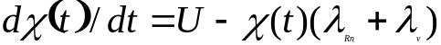
Where χ(t) is the radon activity concentration (Bq/m³)
U is the radon entry rate (Bq/m³*s or pCi/m³-s)
λ_{Rn} is the radon decay constant, and
λ_{v} is the ventilation rate
The solution of the equation is:

(1)
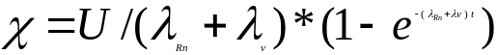
To calculate the maximum concentration, if we assume the ventilation rate in Fac Pond 8 is zero, the formula becomes:

(2)
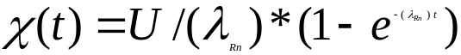

U is the radon entry rate, in units of pCi/ m³-s. To determine the entry rate in the volume of air within Fac Pond8, we multiply the flux (pCi/m²-s) by the ratio of the surface area to the volume or 1/20 ft⁻¹ or 1/6.1 m⁻¹. χ(t) is a function of time. For a long enough time, such as 5 radon half-lives, or 20 days, the radon concentration approaches equilibrium, that is, the amount of radon produced equals the amount that decays. We get 0.275*10⁶ pCi/m³ or 275 pCi/L, as the average radon concentration, with a range of 0.033*10⁶ – 1.12*10⁶ pCi/m³.

The above concentration, 275 pCi/L, exceeds the concentrations OSHA considers hazardous. Specifically, 29 CFR§1910.1096(c)(1) of OSHA's Ionizing Radiation standard, which the agency issued in 1971, requires employers to limit radiation exposures to the levels specified in the Nuclear Regulatory Commission (NRC) radiation standards in effect at the time (10 CFR Part 20, Appendix B, Table I and II). Table 1 of Appendix B to Part 20 sets the maximum permissible concentration for radon-222 at 100 pCi/L. The OSHA standard requires employers to ensure employees are not exposed to radon in excess of the average concentration for 40-hours in any workweek of seven consecutive days (29 CFR §1910.1096(c)(1)).

Lung Dose to Fac Pond 8 Workers

We calculate the lung dose to workers with two methods 1) using the methodology employed for miners, with working levels and working level months and 2) using methodology of the Nuclear Regulatory Commission, with derived air concentrations (DAC) and annual limit on intakes (ALI). The NRC occupational dose limit to an organ, such as the lung, is 50 rem, 10 CFR§ 20.1201(a)(1)(ii).

Working Levels

The calculated concentrations were transformed into working levels (WL). A WL is any combination of the radon progeny in one liter of air releasing 130,000 MeV of alpha energy when decaying. The WL units are historically derived from uranium mining operations. We translate radon concentrations into WL in order to finally arrive at the radiation lung dose to Fac Pond8 workers. The WL were calculated by dividing the concentration by 100 (100 pCi/L Rn-222 per 0.5 WL). The calculated WL are
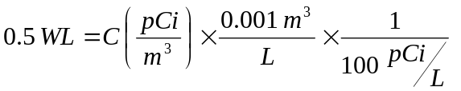
4.5 WL, with a range 0.66 to 22.4 WL.

Working Level Months

The WL is then divided by 170 hours (170 hours in one WL) and then multiplied by the hours worked by the individual to find the working level months (WLM). One WLM is equivalent to a person breathing in one WL for 170 hours. Working level months were developed in order to describe the exposures to radon and radon progeny to workers in underground mines.

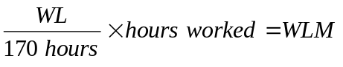

The calculated WLM are: 53, with a range 7.76 to 263.5.

Effective Dose and Lung Dose

The WLM is then multiplied by conversion factors in order to determine the dose to the whole body and lungs in rems.

The air concentrations were converted into rems using the methodology from RESRAD-BUILD to calculate the effective dose. We used the RESRAD-BUILD conversion factor of 1,000 mrem/WLM for radon progeny. Thus, the total effective dose is 53 rems, with a spread 7.76 to 263.5 rems.

We calculated the lung dose using dose conversion factors from the National Research Council's Comparative Dosimetry of Radon in Mines and Homes, a companion to BEIR IV. The dose conversion factors used are for an adult male performing light exercise, and we used the range provided. The lowest conversion factor was 12.44 rem/WLM for active median thermodynamic diameter (AMTD) 0.3 μm particles and the highest conversion factor was 306 rem/WLM for AMTD 0.0011 μm. Since a worker at Fac Pond 8 would have been exposed to both attached and unattached fractions we bounded our calculations with the low and high conversion factors. Assuming 0.3 μm particles, we finally obtain a lung dose of 659 rems, with a spread 96.5 to 3278 rems. The smaller particles, or unattached polonium, bismuth and lead particles, would yield an even higher lung dose.

The above calculations assume no wind, with radon settling within the Fac Pond 8 berms. Not accounting for the wind resistance of the berms, and assuming Fac Pond 8 is 500 feet across, the number of air exchanges in Fac Pond 8 in a 2 mph average wind, is 4.24 E-3/sec, which reduces the lung dose by a factor of 500, or an average lung dose 1.32 rems, with a spread of 0.19 to 6.56 rems. For smaller particles, the lung dose would be increased by a factor of 25. These lung doses should be added to those doses calculated by the correct RESRAD (ver. 7.0), 1.81 mrem/yr, assuming a one foot soil cover, and 21 mrem/yr, assuming no soil cover.

Derived Air Concentrations

The NRC defines the DAC as the concentration of a given radionuclide in air which, if breathed by the reference man for a working year of 2,000 hours under conditions of light work (with an inhalation rate of 1.2 cubic meters of air per hour), results in an intake of one annual limit on intake (ALI). For radon-222, the NRC calculates the DAC for occupational exposures, 3E-5 μCi/L. My calculation of radon in air ranges between 3.3E-5 μCi/L and 1.12E-3 μCi/L. Assuming a worker is in Fac Pond 8 2000 hrs/y, according to NRC methodology, the annual dose to the lung would range between 55 rems and 1867 rems. This exceeds NRC’s allowable occupational limit of 50 rems. If we assume an average wind speed of 2 mph, the lung dose would be lower.

It is important to note that the soil excavation monitoring plan included in CWM’s Part 373 application, does not include radon monitoring. Also, the report, Results of Subsurface Soil and Pond Sediment Sampling for RMU-2, did not sample for radon anywhere, including Fac Pond 8. This could have been easily carried out by taking grab samples and passing the gas through a photomultiplier tube. If the radon concentrations are above derived air concentrations, the workers should wear protective equipment.

Conclusion

For workers in Fac Pond 8, the radiation dose to the lung, taking into account radon, is much higher than calculated by GRD, employing RESRAD. The average radon concentrations exceed the NRC’s derived air concentrations, that is, the radon concentrations are above NRC regulatory limits. Clearly, it is important to account for inhalation exposure in calculating the total effective radiation dose and the lung dose. The GRD RESRAD calculations should be rejected by DEC/DOH and radon monitoring should be required.

URS Subsurface Survey of RMU-2 Footprint

In April 2009, URS conducted a subsurface survey of the RMU-2 footprint, and supporting units Fac Ponds 3 and 5. According to URS, the purpose was “to evaluate the potential for levels of contamination that could pose a potential problem in managing excavated materials during future construction of the site.” In total, 216 soil and sediment samples were sent to a laboratory for detailed isotopic analysis. The URS survey will not satisfy the intended purpose.

Samples were taken in a planned array to cover the entire RMU-2 footprint. The number of samples was far less than at SU9 in Fac Pond 8. For example, in Fac Pond 5, 45 samples were taken over an area approximately 40,000 m², compared to 15 samples over an area 2000 m² in SU9 in Fac Pond 8. That is, the density of samples was almost 7 times greater in SU9. Of the 45 samples in Fac Pond 5, we have the following number of samples at each depth sent to the lab: 7 (0-2 ft), 4 (2-4 fr), 4 (4-6 ft), 4 (6-8 ft), 6 (8-10 ft), 3 (10-12 ft), 10 (12-14 ft) and 7 (14-16 ft).

The proposed plan assumed little contamination would be present in the surveyed areas. “Historical data from DOE and other FUSRAP activities on the property indicate limited potential for subsurface contamination in the portion of the site slated for development.” A careful historical assessment would show the opposite is true.

Further, the analysis protocol cannot satisfy the intended purpose of protecting workers during proposed construction of RMU-2, since the method does not identify and map out in 3 dimensions where the highest gamma readings are located. In other words, the method employed by URS did not map out in three dimensions the soil that should be removed. Each sample taken by URS was analyzed for specific radionuclides at a predetermined depth. So if it was determined that probe at location X was to be analyzed for a depth of 6’ – 8’, that sample was sent to the lab, even if a sample at another depth at location X had a higher gamma dose rate. The sampling protocol should have been the same as in Fac Pond 8, where the entire length of the subsurface probe was scanned. Samples for gamma readings above 1.5 times background should have been sent to the laboratory for detailed isotopic analysis. Judging from the photos provided with the URS report, it appears that URS had taken gamma readings the full length of each probe while in the field. See Fig. 5. In the figure, a worker is scanning the core with a radiation detector. Sampling all cores for gamma radiation would yield a 3-dimensional view of subsurface contamination, and allow CWM to identify the full volume extent of contamination that would have to be remediated. However, gamma logs with depth are not provided in the RMU-2 project application materials.

Soil Excavation Plan

In order to construct RMU-2, CWM will need to excavate greater than 150 cubic meters of soil. As part of the RMU-2 license application, CWM has developed the RMU-2 Project Specific Soil Excavation, Monitoring, Management and Corrective Action Plan (SEMMP). Preliminary to this plan CWM conducted a sitewide radiological surface survey and a subsurface investigation of the proposed footprint area of RMU-2, including those of the supporting operating units, such as Fac Ponds 5 and 8 and others.

In NYSDEC/NYSDOH letter to CWM regarding the SEMMP dated September 5, 2013, the agencies asked whether the sampling plan was consistent with MARSSIM. The agency comments noted that MARSSIM applies to more than “clean closure” or a final status survey. In comment #3, the agencies stated, “If CWM is going to use MARSSIM to demonstrate clean closure of the footprint, the subsurface investigation should have been performed (or at least reviewed) by a licensed contractor. The agencies also noted that MARSSIM applies to a subsurface survey. This is in agreement with NRC guidance on this issue that can be found in Section 1 and 11.1 of Appendix E in NUREG-1727 NMSS Decommissioning Standard Review Plan. NUREG-1727 states: “The number of cores to be taken is the number N required for the WRS or Sign test, as appropriate. However the mixing volume assumed in the scenario may require a larger number of core samples. There is no adjustment to the grid spacing for the elevated measurements comparison because scanning is not applicable."

As we discuss in this section, the CWM surface and subsurface investigations have failed to identify the extent of soil contamination in the RMU-2 footprint and supporting units. One example of this failure is the survey work by EnSol in Fac Pond 8, where SU9 was considered clean, but found to have surface hot spots and considerable subsurface radioactive contamination. CWM uses various arguments to explain its position – its concern for the safety of Rad Techs who might trip, be run over by heavy equipment or OSHA requirements that are inapplicable. Below, we carefully review CWM’s plan and compare it to NRC’s guidance and NYSDOH’s concerns and expectations.

Radiological Scanning

CWM’s plan for radiological screening of potentially contaminated soil, for almost all construction activities, relies on portal monitors and not on surface scanning. For example, CWM plans to conduct clearing and grubbing, before surface scanning the area. Here CWM is concerned that a Rad Tech might trip. This is a strained rationale. Surface scanning does not require a Rad Tech to be burdened with heavy equipment. CWM also states that this operation would disturb only the top six inches of soil. The removal of tree stumps clearly involves cuts deeper than six inches.

For small excavations, the current sitewide permit requires CWM to scan every six inch lift of soil for radioactivity. For mass excavations, CWM maintains that a radiological survey every six inches is impractical with heavy equipment and unsafe for Rad Techs in the presence of this equipment. Instead, CWM is proposing a surface scan before mass excavations “for all areas not previously scanned during the Sitewide Survey.” This assumes the previous sitewide survey was adequate, but as discussed above, it was not. After a survey scan, CWM intends to proceed with mass excavations without prior scanning. This should be compared to the current permit requirements Once soils are excavated under the RMU-2 Project plans, haul trucks carrying the soil would pass through radiation portal monitors. However, portal monitors are unlikely to detect radioactive materials shielded by the load, and shielded by the steel walls of the truck.

For the scanning of deep trenches, CWM proposes scanning every six inches to a depth of four feet. Below four feet, contaminated soil would be loaded into haul trucks and passed through the portal monitors. CWM argues that OSHA prohibits entry into a trench deeper than 4 feet. This is not correct. OSHA's excavation standards at 29 CFR §1926.651(g), Hazardous Atmospheres, requires employers to test for hazardous atmospheres before employees enter excavations greater than four feet in depth. Subsection 1926.651(g)(1)(i) provides examples of hazardous atmospheres, including, but not limited to, oxygen deficiency and air contaminants in landfill areas or by storage areas for hazardous materials. Control measures are specified in §1926.651(g)(1)(ii), which requires employers to take adequate precautions to prevent employee exposure to hazardous atmospheres, including providing proper respiratory protection or ventilation in accordance with 29 CFR Section 1926 Subparts D and E, respectively. Thus, the applicable OSHA rules do not prohibit workers from entering excavations greater than four feet in depth. Instead, the rules require testing and protective equipment at such depths.

Finally for shallow trenches, CWM allows Rad Techs to scan surfaces every 6 inches down to a dept of 4 feet. This raises the question, why this level of protection would not be afforded those working in the excavations for the landfill.

Radiation Detectors and Scanning Procedures

For hand scanning of soils, CWM proposes the use of a standard 2x2 Sodium Iodide (NaI) detector. According to NUREG-1507, the sensitivity of such a detector held at 10 cm or 4 inches above soil is 2.8 pCi/g for Ra-226 (or its decay product Bi-214). According to NUREG-1507 (p. 6-21), the "average height of the Nal scintillation detector above the ground during scanning" should be 10 cm," or four inches. CWM proposes scanning at a 6 inch height above ground surface. Since the background concentration of radium-226 in Western New York is 0.85 pCi/g, the radiation detector will not be sufficiently sensitive to detect concentrations 1.5 times background, or 1.27 pCi/g for Ra-226.

When soil is carried off by haul trucks, portal monitors will be used to survey the contents. As discussed above, in the absence of in situ screening, utilization of truck portals to detect radiologically contaminated soil is inherently unreliable. Substantial volumes of contaminated soils could be excavated, dumped into haul trucks and dumped into surface stockpiles, at each point dispersing contaminants into the environment.

CWM proposes to use the program Microshield to set the investigation and alarm levels for truck portal scans. But, the program and alarm levels should first be benchmarked at the LOOW site. Samples of truck loads of contaminated material should first be measured at a lab, measured by portal monitors and compared with Microshield output. The alarm and investigation levels should be set at 1.5 times background. Speed limits should follow guidance of the manufacturer, at less than 5 mph. If a load exceeds the investigation level, CWM states the load will be dumped in a special area and measured with a handheld detector at a height of 6 inches from the contaminated material. If the contamination is localized, defined as < 10 square feet, it will be packaged for appropriate disposal. Excavation operations will cease. However, there is litle assurance this procedure will be safe, since substantial volumes of potentially contaminated soil would be moved and dispersed before detection. Further, once excavation ceases, the SEMMP is silent on the criteria for restarting excavation operations. The SEMMP is also silent about the case when the contamination is > 10 square feet. This would clearly be a failure of the original subsurface sampling program.

Conclusion

For the reasons provided above, CWM has failed to adequately address the potential impacts to health and the environment of moving massive volumes of potentially radiologically contaminated soil. It therefore cannot begin to develop adequate mitigation measures, or to determine whether acceptable mitigation is available under the circumstances. In addition, basic questions of worker safety are raised by the RMU-2 Project proposal that are either avoided entirely, or are obscured by reference to inapplicable restrictions on the protective measures CWM should have considered but did not, such as testing and protective gear for workers in deep trenches. Clearly, the excavation plans CWM has proposed will require considerable modification and further development. Once CWM has provided sufficient information to meaningfully review its plans for effective characterization of the RMU-2 footprint and other areas planned for soil disturbance, in compliance with applicable radiological investigation guidelines, we look forward to further commenting on those plans. In the absence of effective characterization, there can be no reasonable assurance the project is safe.

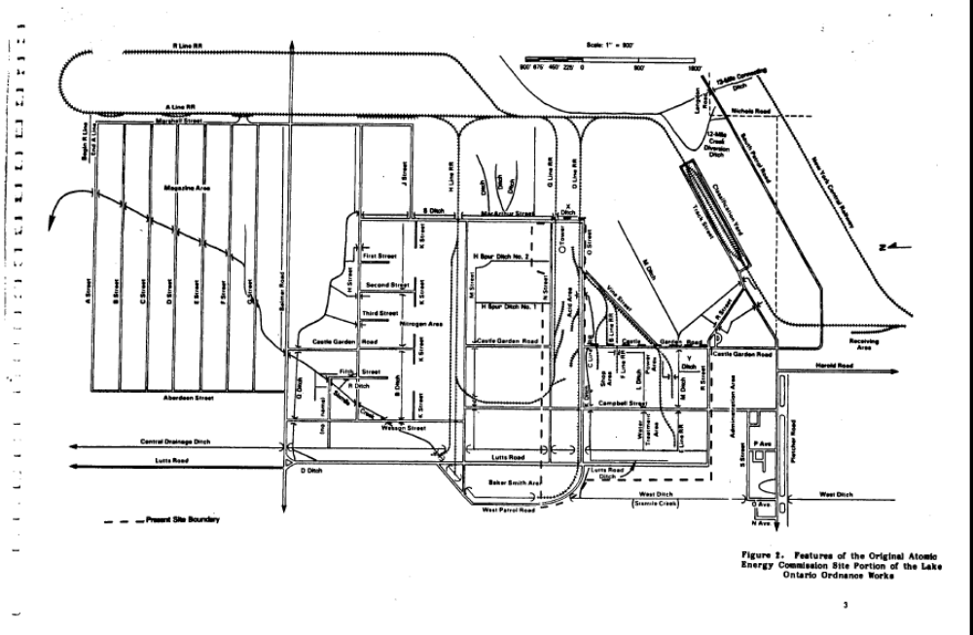
Fig. 1. Original AEC Portion of LOOW
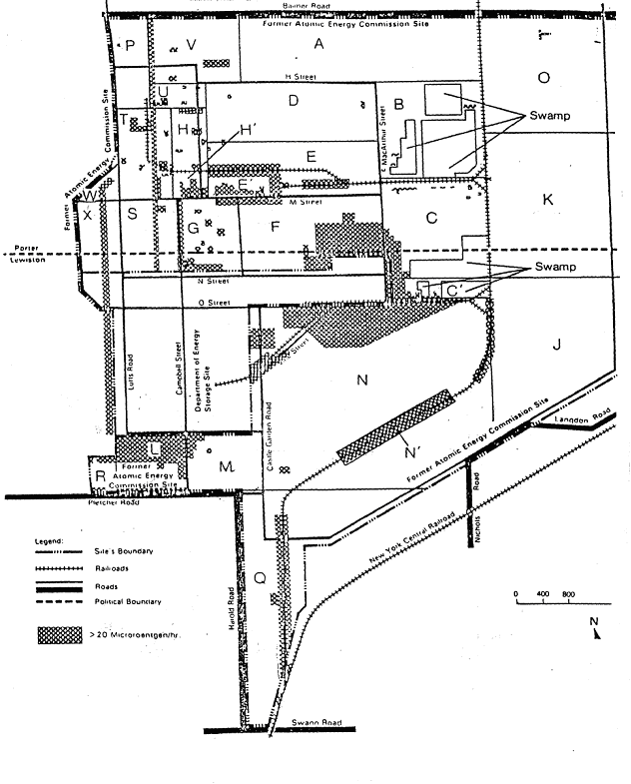
Fig. 2. Surface Gamma Survey 1971 - 1972

Fig. 3 RMU-2 Footprint and Associated Properties

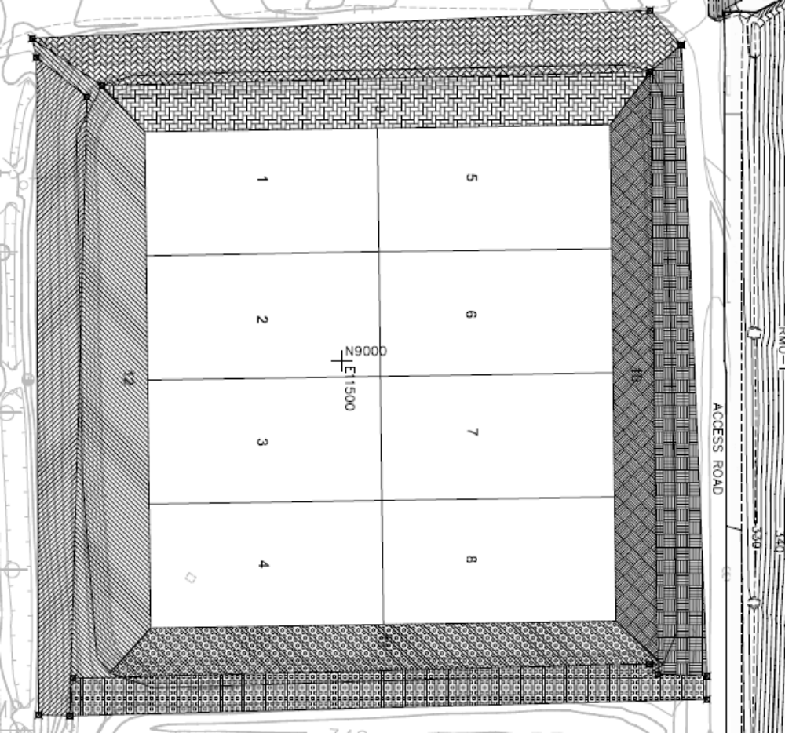

Figure 4. Fac Pond 8, broken into 12 survey units. (LATA, 2012b)
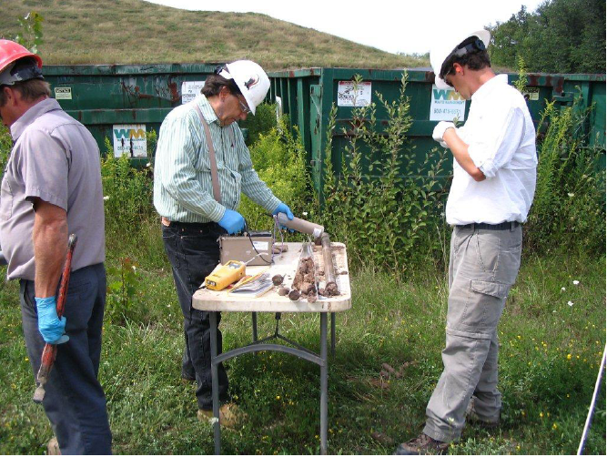

Fig. 5. Core Radiation Scan (URS, 2009)

References

(Aerospace, 1982) THE AEROSPACE CORPORATION, Background and Resurvey Recommendations for the Atomic Energy Commission Portion of the Lake Ontario Ordnance Works, prepared for the Public Safety Division, Office of Operational Safety, Assistant Secretary for Environmental Protection, Safety, and Energy Preparedness, U.S. Department Of Energy, Contract No. DE-AC01-82-EP1510O, November 1982.

(CWM, 2009) CWM Project Specific Soil Excavation, Monitoring, Management and Corrective Action Plan (SEMMP), November 2009, Revised November 2013.

(DEIS, 2013) CWM Chemical Services, LLC, Draft Environmental Impact Statement, Residuals Management Unit 2 (DEIS), Rev Nov 2013, Dwg 8, C20 Initial Fill Progression

(EnSol, 2010) Radiological Characterization Results Final Report for Facultative Pond 8. Rep. Niagara Falls, NY: EnSol, December 2010. Prepared for: CWM Chemical Services, LLC

(Grove, 2008) Grove Software Incorporated, 2008. MicroShield, Version 8.02, Lynchburg, VA. Website URL: www.radiationsoftware.com

(Haywood, 1976) Haywood, FF, WA Goldsmith, PT Perdue, WF Fox, and WH Shinpaugh. 1976. Assessment of Radiological Impact of the Inactive Uranium Mill Tailings Pile at Salt Lake City, Utah. ORNL/TM-5251.

(LATA, 2012a) LATA, Final Status Survey Report for Facultative Pond 8, Survey Units 1-5, 7, 8, 11 and 12, April 2012

(LATA, 2012b) Completion Report for the Subsurface Radiological Investigation of Survey Unit #9 Within Fac Pond 8 At CWM Chemical Services, LLC (CWM) Model City. Rep. no. CWM-REP-WP-002. Westerville, OH: Los Alamos Technical Associates, 2012. Prepared for: CWM Chemical Services, LLC

MARSSIM, 2000, Ch. 3.Multi-Agency Radiation Survey and Site Investigation Manual (MARSSIM), Nuclear Regulatory Commission, NUREG-1575, Rev. 1, AUGUST 2000, Chapter 3.

(Myrick, 1983) T. Myrick, et al., Oak Ridge National Laboratory, State Background Radiation Levels, (ORNL/TM-7343), 1983, available at <http://web.ornl.gov/info/reports/1981/3445605600481.pdf.

(National Research Council, 1991) National Research Council. 1991. Comparative Dosimetry of Radon in Mines and Homes. Companion to Health Risks of Radon and Other Internally Deposited Alpha-Emitters, BEIR IV. National Academy Press.

(ORAU, 1984) J. D. Berger, Comprehensive Radiological Survey: Off-Site Property C, Niagara Falls Storage Site, Lewiston, New York (ORAU Final Report, March 1984)

(RESRAD, 2014) RESRAD for Windows. Computer software. Vers. 7.0, Argonne National Labs, U.S. Department of Energy, U.S. Nuclear Regulatory Commission, Feb 2014.

(RWMA, 2009) Jackie Travers, J and Resnikoff, M, Ph.D., Critique of CWM Walkover Survey & Radiological Investigation, March 2009.

(Tennery, 1978) p. A2-4, Tennery, VJ, ES Bomar, WD Bond, LE Morse, HR Meyer, JE Till, and MG Yalcintas.1978. Environmental Assessment of Alternate FBR Fuels: Radiological Assessment of Airborne Releases from Thorium Mining and Milling. ORNL/TM-6474. October.

(URS, 2009) Results of Subsurface Soil and Pond Sediment Sampling for RMU-2, by URS, April 2009.

(MARSSIM, 2000), Ch. 3
(Aerospace, 1982)
“Vicinity Properties” are remediation areas designated by the U.S. Department of Energy (DOE) outside the Niagara Falls Storage Site (NFSS), a portion of the larger Lake Ontario Ordance Works (LOOW) that includes Model City and the NFSS. These properties, like much of the LOOW, were generally mismanaged radioactive and hazardous waste dump and transport sites that DOE incompletely and unsuccessfully remediated. Today the NFSS and Vicinity Properties have been put under the jurisdiction of the U.S. Army Corps of Engineers (USACE) for further investigation and remediation. However, USACE’s work at Model City remains hampered due to active uses of these areas.
The DEIS, at Fig. 3-13, provides a map of all Vicinity Properties at the Model City site.
(URS, 2009)
(RWMA, 2009)
BNI, 1992. Certification Docket for the Remedial Action Performed at the Niagara Falls Storage Site Vicinity Properties in Lewiston, New York, from 1983 through 1986. Prepared for Department of Energy by Bechtel National Inc., Former Sites Restoration Division, Oak Ridge Field Office, July 1992.
ORAU, 1984a. Comprehensive Radiological Survey, Off-Site Property D Niagara Falls Storage Site Lewiston, New York, Final Report, Oak Ridge Associated Universities, May 1984.
CWM, 2008. Appendix A, pp. A-14, A-17, A-19, A-25.
Kaye, M.E., and Feldman, A.M., 1989. Post-Remedial Action Report for the Niagara Falls Storage Site Vicinity Properties-1985 and 1986. Bechtel National, Inc., Oak Ridge, TN, January 1989.
BNI, 1992.
ORAU, 1984b. Comprehensive Radiological Survey, Off-Site Property E Niagara Falls Storage Site, Lewiston, New York, Final Report, May 1984.
CWM. 2008, pp. A-10, A-22, A-45, A-52.
Ibid., p. A-31
Ibid.
Memorandum from J. Berger to C. Yarbro, ORAU, July 1982.
U.S. ACE, 1999. Technical Memorandum: Radiological Human Health Assessment for the E’ Vicinity Property of the Niagara Falls Storage Site, United States Army Corps of Engineers, March 1999.
ORAU, 1984c. Comprehensive Radiological Survey, Off-Site Property G, Niagara Falls Storage Site, Lewiston, New York, Final Report, February 1984.
Ibid.
(DEIS, 2013)
(EnSol, 2010)
Ibid, p. 1-2.
(ORAU, 1984)
Ibid., 2
(LATA, 2012a)
(LATA, 2012b)
(EnSol, 2010). Note that Ensol is not a contractor licensed by the State of New York.
(LATA, 2012b)
(RESRAD, 2014)
(Tennery, 1978)
Ibid
(Haywood, 1976)
(Tennery, 1978)
(National Research Council, 1991)
Ibid
Ibid
(National Research Council, 2001)
(CWM, 2009)
(URS, 2009)
Ibid.
(CWM, 2009)
Letter from Richard E. Fairfax, Director, Directorate of Enforcement Programs, OSHA, to Thomas Van Hooser, dated December 28, 2009, available at https://www.osha.gov/pls/oshaweb/owadisp.show_document?p_table=INTERPRETATIONS&p_id=27275
( Myrick, 1983) Myrick, T, et al, Using a Geiger-Mueller detector, gamma ray measurements taken 1 meter from the soil surface resulted in average Ra-226 concentrations in soil at several locations in Niagara County of 0.85 pCi/g.
(Grove, 2008)

