**Review of CWM Radioactive Sampling Program**

**In the Proposed RMU-2 Development Areas**

October 2015

On behalf of Niagara County

By

Marvin Resnikoff, Ph.D.

Radioactive Waste Management Associates

**Summary**

This report reviews the proposed specific soil excavation monitoring and management plan (SEMMP) released by Chemical Waste Management (CWM) May 2015. As part of the RMU-2 license application, CWM has developed the RMU-2 Project Specific Soil Excavation, Monitoring, Management and Corrective Action Plan (SEMMP)[1]. In order to construct RMU-2, CWM will need to excavate greater than 150 cubic meters of soil, hence the need, under its permit, to produce a plan. Preliminary to this plan CWM has conducted a sitewide radiological surface survey and a subsurface investigation of the proposed footprint area of RMU-2, including those of the supporting operating units, such as Fac Ponds 5 and 8 and others. This program consisted of a gamma walkover surface survey and subsurface investigation of the RMU-2 footprint, with a more detailed investigation of facultative pond 8 (FacPond 8).

As we wrote in our comments one year ago, we have little confidence that the CWM investigations are capable of detecting, with reasonable certainty, the radioactive contamination remaining on the CWM property, and whether it forms an adequate basis for the soil excavation plan (SEMMP). We feel more so now that we have examined in detail the state of Facultative Pond 8, FP8, as we discuss below. CWM continues to rely on DOE’s certification of the vicinity properties (VP). However, VP C, where FP8 is located, was certified as clean, and it turns out anything but. This raises concern for many of the other areas of proposed RMU-2, which are likely to be contaminated.

In our view, there are two ways to proceed with this radioactively contaminated site. CWM proposes SEMMP, which in its essence, is to begin the construction of RMU-2. If a truckload of soil is contaminated, the material would be placed in a spoils pile for later determination. In our judgment, some areas of the site which are highly contaminated, would be dug up, exposing workers to the contamination. An alternative method is to carefully sample and monitor regions of the site which are likely to be contaminated. This would be the MARSSIM approach, expending resources in areas which are likely to be contaminated, region 1 in MARSSIM-speak. Less resources would go into areas that are not likely to be contaminated, region 3. A historical assessment should be the guide. An important example is FP8, as we discuss next.

## Fac Pond 8 – a Guide What to Do and What Not to Do

On September 15, 2015, CWM submitted an “Excavation Monitoring Plan for Facultative Pond Number 8 (FP8) Survey Unit Number 9 (SU9).” This plan calls for the remediation of SU9, one of the berms, and the placement of a 1-foot cover over the vein of radioactive material discovered in SU9, which had not been previously remediated.

In our opinion, this excavation request for FP8 must be placed in a larger context. It is our view that the all the berms in FP8, (SU9-12) which were constructed from the same radioactive source as SU9, have not been properly examined and are likely to be as contaminated as SU9. Neither the historical record, nor the radioactive examination by the contractors EnSol and LATA give confidence that these berms could pass a final status survey and are likely to be similarly contaminated. All four berms should be properly monitored and excavated before RMU-2 work can begin in FP8.

## Original Construction of Berms SU9-12

## On April 1978,Wehren Engineering, requested permission to excavate lagoon 8. The bottom elevation of lagoon 8 was 309’, the top elevation, 323’. A mere 10 months later, as an emergency measure, on November 21, 1978, Wehren Engineering asked that the height of the berms be increased an additional 10 feet, to 333 ft, the present height of the berms. The soil for the additional height was obtained from glacial tills “located in the area directly east of lagoon No. 8.” Though this area, known as VP C, was an area of waste storage, none of this additional material was tested for radioactivity in 1978. A 1971 – 1972 AEC survey[2] identified surface contamination near the southwest corner of Area C, where Fac Pond 8 is located. Oak Ridge Associated Universities (ORAU) stated, “This finding suggests possible storage or shallow burial of contaminated material may have occurred.” Since, as we see below, the 66 tons of radioactive contamination excavated from SU9 came from within the top 3 feet of berm SU9, it is likely the material deposited by Wehren Engineering in 1978 to heighten the berms came from the area east of the lagoon. This means it is likely that all four berms SU9-12 were similarly contaminated.

Appendix E, which is attached, details the radioactive concentrations for the composites from SU6, 9 and 10. As seen, while U-238 has a concentration 5.48 pCi/g, Ra-226 has a concentration 191 pCi/g. This strongly indicates this is uranium tailings, waste obtained by removal of U-238 from uranium ore, and likely derived from one of the chemical plants in the Niagara Falls area during the Manhattan Project.

## Construction of Cell 20, RMU-2

To construct cell 20, RMU-2, berms 9, 10 and 11 have to be lowered to 320’ from 333’, as seen in the attached Fig.3 (attached) from the RMU-2 application. This means all the material, likely contaminated, that was added in 1978 will be removed. It also appears that berm 12 will be completely removed.

## Based on the history of FP8 and the contamination in SU9 and 10, we consider it likely that considerable contamination will be found in the berms when the height is lowered to 320’. In addition, a vein of elevated radiological contamination was found in the middle of SU9. The proposed surface scan by CWM will not detect radioactive contamination from the hotter mill tailings or the vein of contamination within the berms, as CWM requested in their September 2015 letter to NYSDEC. What is required is a careful subsurface monitoring of all four berms.

## Construction of Cell 20, RMU-2

To construct cell 20, RMU-2, berms 9, 10 and 11 have to be lowered to 320’ from 333’, as seen in the attached Fig.3 (attached) from the RMU-2 application. This means all the material, likely contaminated, that was added in 1978 will be removed. It also appears that berm 12 will be completely removed.

Based on the history of FP8 and the contamination in SU9 and 10, we consider it likely that considerable contamination will be found in the berms when the height is lower to 320’. In addition, a vein of elevated radiological contamination was found in the middle of SU9. The proposed surface scan by CWM will not detect radioactive contamination from the hotter mill tailings or the vein of contamination within the berms, as CWM requests in their September 2015 letter to NYSDEC. What is required is a careful subsurface monitoring of all four berms so that the location and volume of the radioactive sources can be determined, and excavation and can be carefully and safely removed.

In our view, particular attention should be paid to areas of the proposed footprint that were previously contaminated, rather than sparsely surveying the entire proposed footprint. CWM’s contractors should have first carried out a historical assessment. While a gamma walkover survey is one screening method, as illustrated in FacPond 8, it is entirely unsatisfactory for detecting subsurface contamination. The URS subsurface examination of the proposed RMU-2 footprint, if carried out correctly, would have been effective in identifying radioactive contamination, but it also had fatal defects that render it untrustworthy.

## Historical Assessment

None of the contractors conducted a historical assessment to determine where radioactive waste was stored or buried. Before undertaking a screening or detailed survey, one should know where to look. This is recommended by MARSSIM[3]. MARSSIM is more than a guide for a final status survey. It is a “systematic approach for planning, conducting, evaluating, and documenting environmental radiological surveys.”

According to MARSSIM an historical site assessment “identifies potential, likely, or known sources of radioactive material and radioactive contamination based on existing or derived information.” This serves as a guide on whether the unit is impacted by contamination or not. This is information that is useful to scoping and characterization surveys.

A 1982 report by Aerospace Corporation[4] is especially useful in characterizing the properties owned by CWM. That report details, after a review of historical documents, the quantities of radioactive materials brought to the LOOW site and where this material was stored or buried. The attached fig. 2 shows the original Atomic Energy Commission site portion of LOOW. While other figures in the report show where radioactive material was disposed or stored, for our purposes, Figure 9, also attached, is the most useful. Figure 9 is a summary of a gamma survey conducted in the 1971-1972 time frame. Higher dose rates were present near railroad tracks in vicinity property E and in vicinity properties C and F. Some of those areas lie in the RMU-2 footprint. In particular, Fac Pond 3 lies in vicinity property F and Fac Pond 8 lies in vicinity property C. Proposed landfill RMU-2 lies in vicinity properties C, E and F. The regions of these vicinity properties, where gamma dose rates are higher, are shown in Fig. 9. It is important to note that Fig. 9 shows gamma dose rates due to surface contamination and not subsurface contamination. CWM acknowledges that a portion of the former railroad line north of “M” Street is located within the footprint of RMU-2. “Based on previous investigations, residual contamination remains in this area. The railroad bed material and residual contamination will be excavated and will be segregated and characterized for disposal.” Based on this contamination, MARSSIM would classify the RMU-2 footprint as category 1 impacted.

## URS Subsurface Survey of RMU-2 Footprint

URS conducted a subsurface survey of the RMU-2 footprint[5], and supporting units Fac Ponds 3 and 5, in April 2009. Fac Pond 8 was studied separately. According to URS, the purpose was “to evaluate the potential for levels of contamination that could pose a potential problem in managing excavated materials during future construction of the site.” In total, 216 soil and sediment samples were sent to a laboratory for detailed isotopic analysis. In my opinion, the URS survey will not satisfy the intended purpose.

Samples were taken in a planned array to cover the entire RMU-2 footprint. The number of samples was far less than at SU9 in Fac Pond 8. For example, in Fac Pond 5, 45 samples were taken over an area approximately 27,000 m2, compared to 15 samples over an area 2000 m2 in SU9 in Fac Pond 8. That is, the density of samples was 4.5 times greater in SU9.

More importantly, the analysis protocol cannot satisfy the intended purpose of protecting workers during proposed construction of RMU-2, since the method does not identify and map out in 3 dimensions where the highest gamma readings are located. That is, the method employed by URS does not map out in three dimensions the soil that should be removed. Each sample taken by URS was analyzed at a predetermined depth. So if it was determined that probe at location X was to be analyzed for a depth of 6’ – 8’, that sample was sent to the lab, even if another depth at location X had a higher gamma dose rate. The protocol should have been the same as in Fac Pond 8. The entire probe depth should have been surveyed in the field for gamma, with either a pancake or 2 x 2 NaI detector. Samples for gamma readings above 1.5 times background should have been sent to the laboratory for detailed isotopic analysis. Judging from the photos provided with the URS report, it appears that URS has taken gamma readings the full length of each probe while in the field. If URS does have a gamma log with depth for each sample location, this should be provided to DEC.

## Soil Excavation Plan SEMMP

As part of the RMU-2 license application, CWM has developed the RMU-2 Project Specific Soil Excavation, Monitoring, Management and Corrective Action Plan (SEMMP)[6]. In order to construct RMU-2, CWM will need to excavate greater than 150 cubic meters of soil, hence the need, under its permit, to produce a plan. Preliminary to this plan CWM has conducted a sitewide radiological surface survey and a subsurface investigation of the proposed footprint area of RMU-2, including those of the supporting operating units, such as Fac Ponds 5 and 8 and others.

In NYSDEC/NYSDOH letter to CWM regarding the SEMMP dated September 5, 2013, the State asked whether the sampling plan was consistent with MARSSIM. The State recognized in its comments that MARSSIM applies to more than “clean closure” or a final status survey. In comment #3, the State stated, “If CWM is going to use MARSSIM to demonstrate clean closure of the footprint, the subsurface investigation should have been performed (or at least reviewed) by a licensed contractor. The State recognized in its comment that MARSSIM applies to more than surface scanning, but also to a subsurface survey. This is in agreement with NRC guidance on this issue that can be found in Section 1 and 11.1 of Appendix E in NUREG-1727 NMSS Decommissioning Standard Review Plan. NUREG-1727 states: “The number of cores to be taken is the number N required for the WRS or Sign test, as appropriate. However the mixing volume assumed in the scenario may require a larger number of core samples. There is no adjustment to the grid spacing for the elevated measurements comparison because scanning is not applicable."

As we discuss in this section, in my opinion, the CWM surface and subsurface investigations have failed to identify the extent of soil contamination in the RMU-2 footprint and supporting units. One example of this failure is the survey work by EnSol in Fac Pond 8, where SU9 was considered clean, but found to have surface hot spots and considerable subsurface radioactive contamination. Rather than conducting a careful survey to identify the location and extent of radioactive contamination in the RMU-2 footprint and supporting units, CWM simply wishes to get on with the work of constructing RMU-2, loading up haul trucks and dumping contaminated soil into a spoils pile. CWM uses various arguments to explain its position – its concern for the safety of Rad Techs who might trip, be run over by heavy equipment or OSHA requirements, that are completely inapplicable. Though it’s hard to take some of these arguments seriously, we carefully review CWM’s plan and compare it to NRC’s guidance and NYSDOH’s concerns and expectations.

## Radiological Scanning

To summarize, CWM’s plan for radiological screening of potentially contaminated soil, for almost all construction activities, is to rely on surface scanning, which is time consuming and expensive. For clearing and grubbing, CWM wishes to first do this work before surface scanning the area. Here CWM is concerned that a Rad Tech might trip. This is a strained rationale. Surface scanning does not require a Rad Tech to be burdened with heavy equipment. CWM also states that this operation would disturb only the top six inches of soil. The removal of tree stumps clearly involves cuts deeper than six inches.

For mass excavations, CWM maintains that a radiological survey every six inches is impractical with heavy equipment and unsafe for Rad Techs in the presence of this equipment. Here CWM is proposing a surface scan before mass excavations “for all areas not previously scanned during the Sitewide Survey.” This assumes the previous sitewide survey was adequate, which we dispute. After a survey scan, CWM intends to proceed with mass excavations and the use of portal monitors.

For the scanning of deep trenches, CWM proposes scanning every six inches to a depth of four feet. Below four feet, contaminated soil would be loaded into haul trucks and scanned elsewhere. Here CWM argues that OSHA prohibits entry into a trench deeper than 4 feet. The fact is – it is possible to lower a detector into a deep trench to determine whether the count is above background – without personnel entering the trench.

Finally for shallow trenches, CWM allows Rad Techs to scan surfaces every 6 inches down to a dept of 4 feet.

## Radiation Detectors and Scanning Procedures

For hand scanning of soils, CWM proposes the use of a standard 2x2 NaI detector. According to NUREG-1507, the sensitivity of such a detector held at 10 cm or 4 inches above soil is 2.8 pCi/g for Ra-226 (or its decay product Bi-214). According to NUREG-1507 (p. 6-21), the "average height of the Nal scintillation detector above the ground during scanning" should be 10 cm," or four inches. CWM proposes scanning at a 6 inch height above ground surface. Since the background concentration of radium-226 in Western New York is 0.85 pCi/g[7], it appears the radiation detector will not be sufficiently sensitive to detect concentrations 1.5 times background, or 1.27 pCi/g for Ra-226.

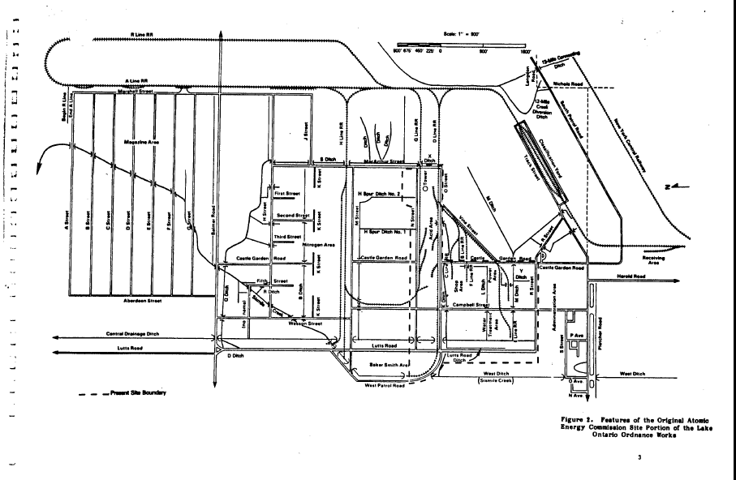

**November 2009**



**Figure 1. Fac Pond 8, broken into 12 survey units. (LATA, 2012c)**





1. CWM Project Specific Soil Excavation, Monitoring, Management and Corrective Action Plan (SEMMP), November 2009, Revised November 2013.
2. (ORAU, 1984)
3. Multi-Agency Radiation Survey and Site Investigation Manual (MARSSIM), Nuclear Regulatory Commission, NUREG-1575, Rev. 1, AUGUST 2000, Chapter 3.
4. Background and Resurvey Recommendations for the Atomic Energy Commission Portion of the Lake Ontario Ordnance Works, prepared for the Public Safety Division, Office of Operational Safety, Assistant Secretary for Environmental Protection, Safety, and Energy Preparedness, U.S. DEPARTMENT OF ENERGY, by THE AEROSPACE CORPORATION, Contract No. DE-AC01-82-EP1510O, November 1982.
5. URS April 2009
6. CWM Project Specific Soil Excavation, Monitoring, Management and Corrective Action Plan (SEMMP), November 2009, Revised November 2013.
7. T. Myrick, et al., Oak Ridge National Laboratory, State Background Radiation Levels, (ORNL/TM-7343), 1983, available at <http://web.ornl.gov/info/reports/1981/3445605600481.pdf. Using a Geiger-Mueller detector, gamma ray measurements taken 1 meter from the soil surface resulted in average Ra-226 concentrations in soil at several locations in Niagara County of 0.85 pCi/g.